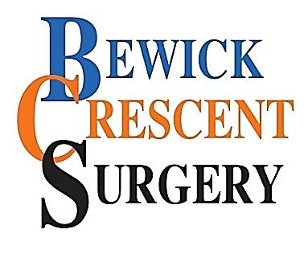 |  | BEWICK CRESCENT SURGERY,  NEWTON AYCLIFFE,  COUNTY DURHAM,  DL5 5LH  Tel: 01325 316637 www.bewickcrescentsurgery.nhs.net
High Quality
Family Medicine

PATIENT ONLINE REGISTRATION FORM – ACCESS TO GP ONLINE SERVICES

- Introduction. GP online services allows you to access a range of services by your computer, mobile or tablet. Once you've signed up you will be able to:

  - Book or cancel appointments online.

  - Renew or order repeat prescriptions online.

  - View parts of your GP record, including information about medication, allergies, vaccinations, previous illnesses, and test results.

You can still contact the practice by phone or in person. More information including 'how to' leaflets on GP online services can be found here: www.nhs.uk/gponlineservices.

- How to sign up. Please complete this form and hand it in to our reception team. It requires both a wet signature and supporting identification and proof of address. You can also collect a copy of this form from our reception at your convenience.

PATIENT ACCESS TO MEDICAL RECORDS – REQUEST FORM
- Details of the Record to be Accessed:

Patient Surname
Patient Forename(s)
Date of Birth
Telephone Number
NHS Number
Address

Email address

- I wish to have online access to the following (tick):

Appointment Bookings (booking, cancelling, and rearranging)
Request Repeat Prescriptions
View Test Results & Vaccination status

- Signature. By signing below, I can confirm I am the above person and the identification I have provided to support this application is legally genuine.

Signed
Date

Office Use Only:

Identity verified by:
Date
Authorised by:
Date
Date Account Created:

Prospective data from date of registration will only be issued.

