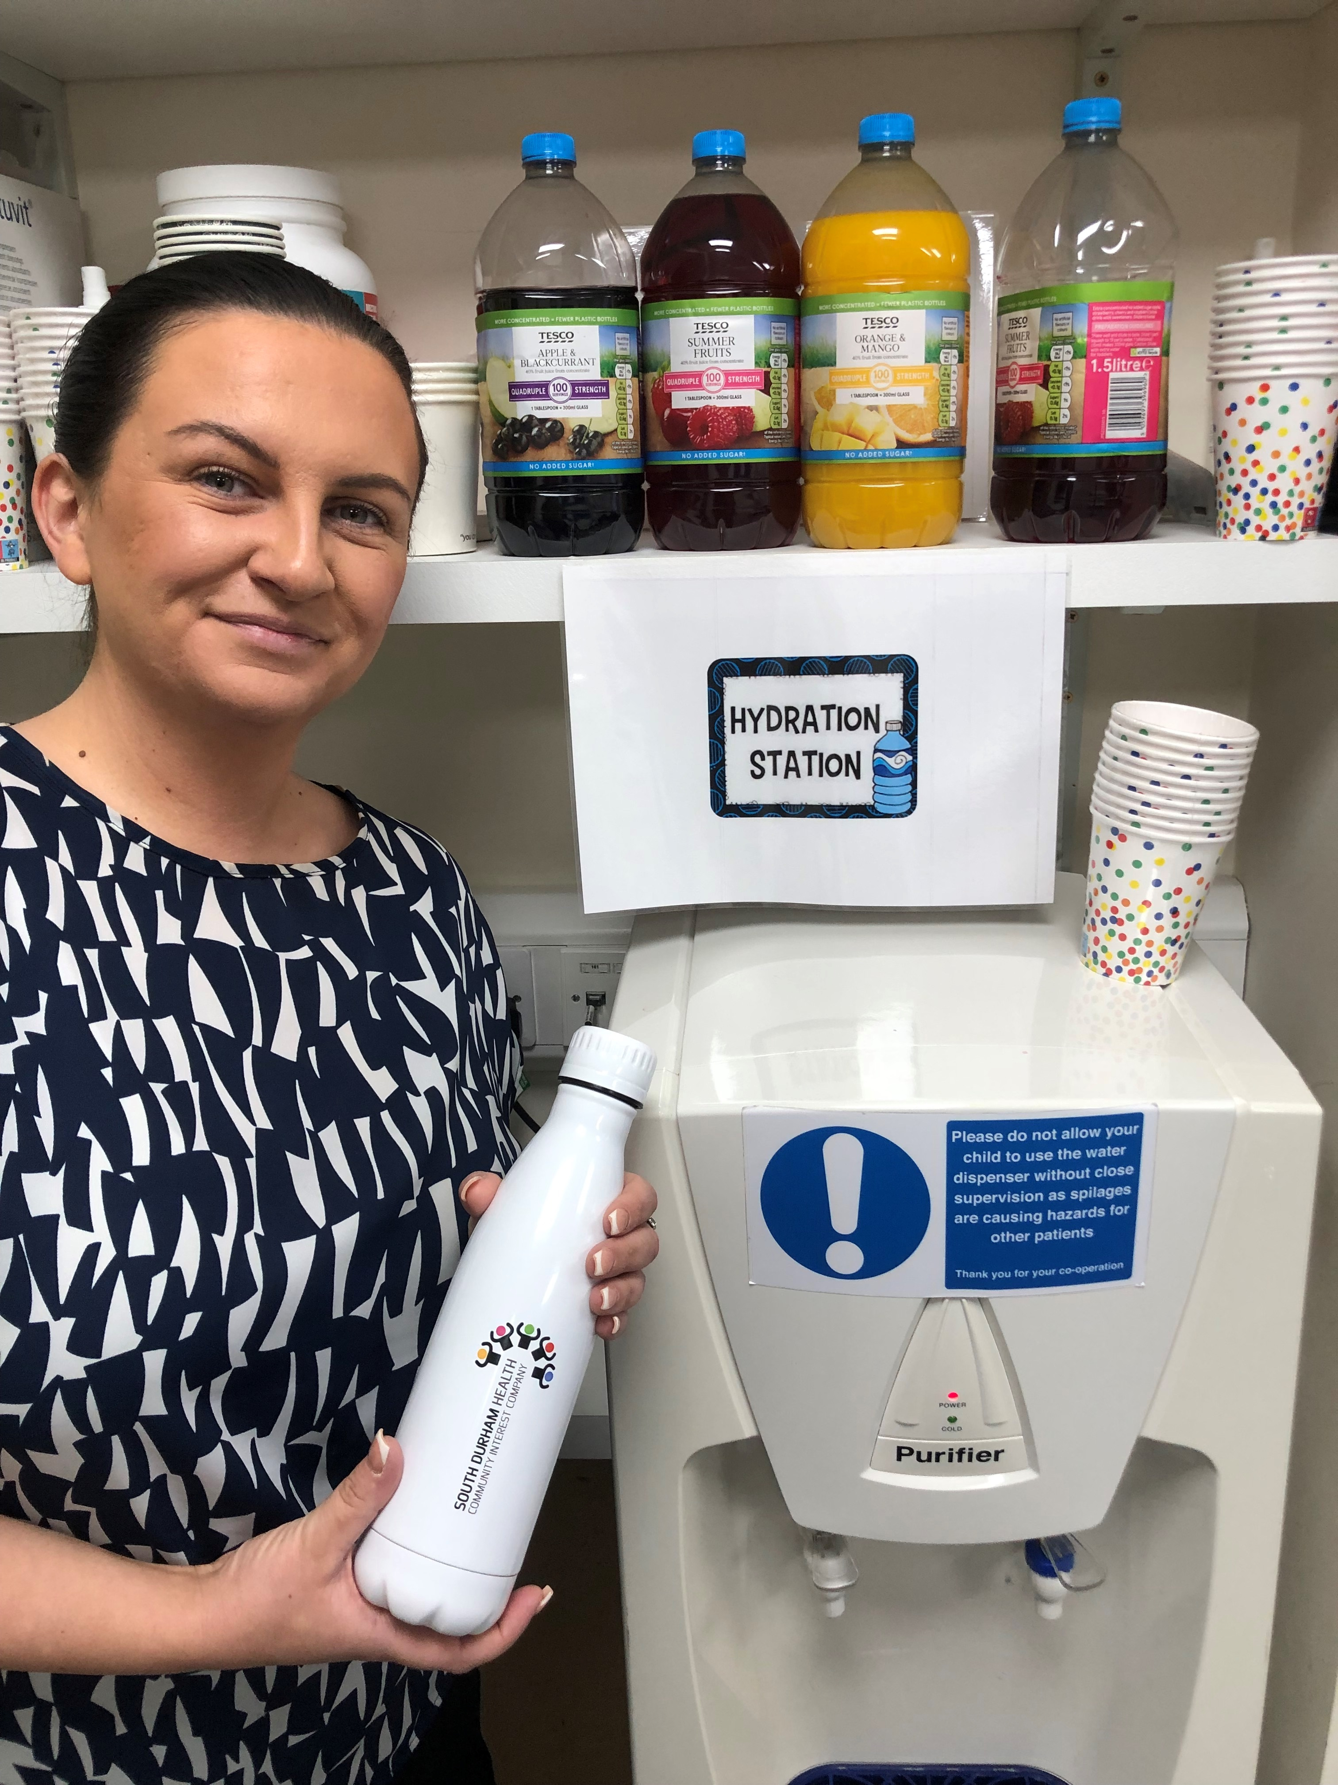

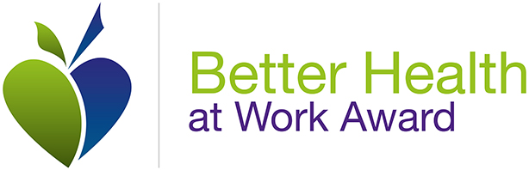
February 2024
Welcome to our FIRST NEWSLETTER

As you will be aware we are aiming to achieve our Better Health at Work
BRONZE AWARD

This Newsletter is to keep you updated with what we have achieved so far and what our next steps will be.  Our Campaigns  As part of achieving our Bronze Better Health at Work Award we need to carry out 3 campaigns.  Following the Questionnaire completed by staff – THANK YOU – we had 61% returned, which is amazing, we have taken direction from these results to guide us as to which areas we should base our campaign. The campaigns are:-  - Healthy Eating and Alcohol  - Sleep and Mental Health  - Physical Activity |  | Hydration Station  Just in case anyone hasn't realised we now have a hydration station in the meeting room, so aswell as the water cooler we now have a selections of sugar free juices.  Everyone should have recieved their free water bottle, This is part of our better health at work scheme, and i would appreciate any feedback as to whether this encourages you to drink more caffeine free fluids during the day at work.
Employees benefit from a healthier environment and culture, increased access to health information and interventions where they wouldn’t normally.

At the same time, employers' benefit from improved staff engagement and retention, lower levels of absenteeism and increased productivity

SLEEP AND MENTAL HEALTH
When collating the information from the Survey staff completed as part of our better health at work scheme, high on the list was trouble with sleeping, this is our first campaign:  As a result to try and help with this problem we now have available for all staff a helpful 'pack' which includes Rules of Healthy Sleep and a night time organic tea bag. Please feel free to pick up your pack which are in the staff room.  We would appreciate any feedback as to whether this helps once you use it.  Also as part of our Better Health At Work we asked staff to share any tips they have on sleeping better.  We have had a good response and they are now displayed on our Better Health At Work notice board.  Any suggestions you have are welcome, if it helps you the chances are it will help someone else.  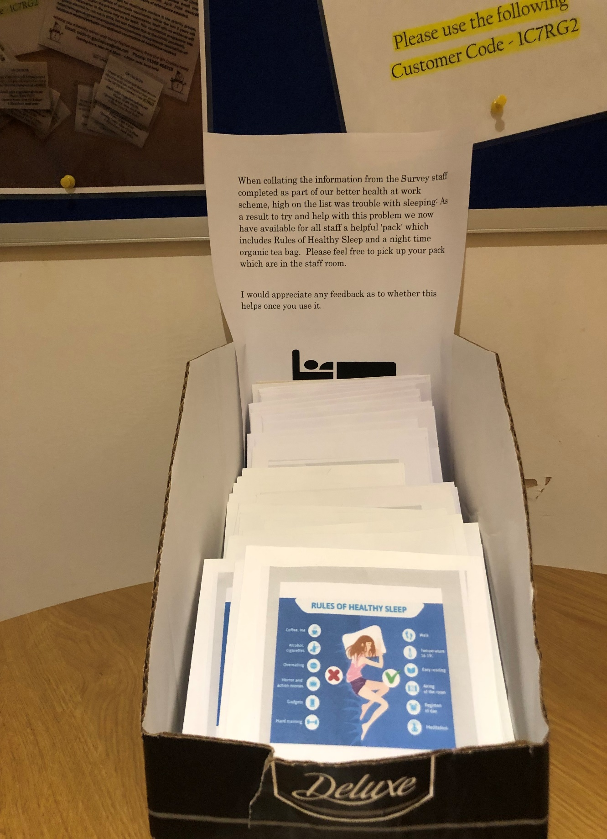  Jan & Jo Your Health Advocates. |  |  | Reading is to the mind what exercise is to the body.  If anyone has any unwanted books we now have a reading shelf in the rest room for people to bring books in and take books, this is part of our healthier at work project, as reading is good for our mental health and relaxation.  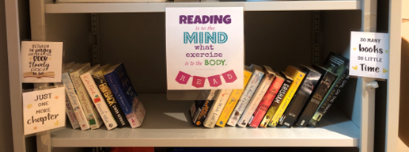  Watch Out in our next  Newsletter for an update on  Healthy Eating and Alcohol.
Another Headline Here | You can easily change the formatting of selected text in the document text by choosing a look for the selected text from the Styles gallery on the Home tab.

